Mechanical engineering case
Gulsim Azirakhmet
ENGR-AD 1000, Fall 2021
Problem Identification and Statement
The goal of this assignment is to develop a software to generate a computer simulation of wind speed for a flight simulator.

Gathering of Information and Input and Output Description

The software assumes a file exists with the simulation configuration. The file, named “simulationConfiguration.txt”, should store the parameters for the wind simulation. The first line stores the wind simulation configurations, namely the average speed, gust value, duration, and step size). The second line stores the storm simulation parameters, namely the storm probability, the minimum and maximum storm amplitude, and the minimum and maximum storm duration values. The third line stores the microburst parameters, namely thee microburst probability, the minimum and maximum burst amplitude, and the minimum and maximum microburst duration values.
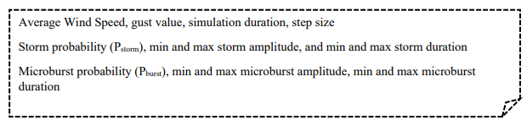
The program reads the average wind speed, the gust value, the duration and step size of the wind speed simulation from the “simulationConfiguration.txt” file (first line). The program should generate a data file named “WindSpeedData.txt” that contains the simulated wind speeds. The time should always start with 0 seconds. Each line of the “WindSpeedData.txt” file should contain the time in seconds and the corresponding wind speed. The wind speed is a random number between the (average speed + gust value) and the (average speed - gust value).

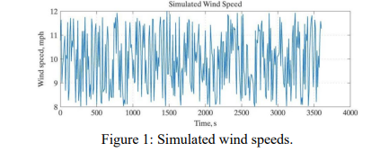
The wind speed simulation must include storm simulation. Assuming that the possibility of encountering a storm at each time step is Pstorm, the program must add a storm magnitude (a random number between the minimum and maximum storm amplitude values) to the simulated wind speed for a duration T (a random number between the minimum and maximum storm duration). The storm parameters are read from the “simulationConfiguration.txt” configuration file (second line). The storm simulation data must be stored in the file “StormData.txt”.
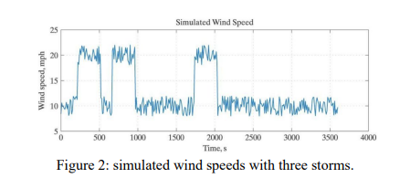
The storm simulation must also include a simulation of microbursts. Microburst are simulated using three parameters: the possibility of encountering a microburst at each time step in a storm (Pburs), the burst amplitude (a random number between the minimum and maximum microburst amplitude values), and the duration of the burst (a random number between the minimum and maximum storm duration values). The burst parameters are read from the “simulationConfiguration.txt” configuration file (third line). The microburst data must be stored in the file “BurstData.txt”.
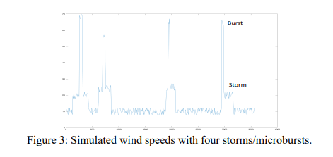
Data file named “WindSimulation.txt” will store wind speed, storm and burst data.
Input and Output description:
WindSpeedData.txt
simulationConfiguration.txt StormData.txt
BurstData.txt
WindSimulation.txt
In file named simulationConfiguration there are 3 lines with information needed for creation of simulation of wind speed, wind speed with storm and wind speed with storm and microburst. In 1st line there are information : average Wind Speed, gust value, simulation duration, step size, about wind speed, which we use for creation of file WindSpeedData. In 2nd line there are information : storm probability (Pstorm), min and max storm amplitude, and min and max storm duration, about storm data, which we use for creation of file StormData. In 3rd line there are information : microburst probability (Pburst), min and max microburst amplitude, min and max microburst duration, about burst data, which we use for creation of file BurstData.
Test Cases and Algorithm Design
Test cases:
Test case 1: for checking WindSpeed.txt values
Test case 1.1: Gust value selection
Enter different gust values.
Program should display wind speed between average wind speed+gust value and average wind speed-gust value in WindSpeed.txt.
Example: average wind speed = 15, gust value = 5, simulation duration = 1 hour, stepsize = 10 seconds

Time | Wind speed
0
10 | Wind speed should be a random value between 15 and 20

Test case 1.2: Simulation duration and stepsize
Enter different simulation duration values
Program should display wind speed values throughout the given simulation duration value with the given stepsize.
Example: average wind speed = 15, gust value = 5, simulation duration = 2 hour, stepsize = 20 seconds

Time | Wind speed
0
Time should start with 0 and end with 7200. The stepsize is 20 seconds, meaning time displays as: 0, 20, 40, 60, 80, 100 ...till the 7200. | Wind speed should be a random value between 15 and 20

Test case 2: for checking StormData.txt values
Test case 2.1: Storm probability selection
Enter different storm probability values.
Program should display wind speed values with added storm value when randomly generated probability is equal or smaller than given storm probability.
Example: storm probability = 0.5, min storm amplitude = 5, max storm amplitude = 10, min storm duration = 3, max storm duration = 5
Program should display wind speed values with added storm value when randomly generated probability is equal or smaller than 0.5. The storm value is random value between 5 and 10, also storm lasts for the random duration between 3 and 5.
Test case 2.2: Min and max storm amplitude selection
Enter different min and max storm amplitude values.
Program should display wind speed values with added storm value which is the value between min and max storm amplitude.
Example: storm probability = 0.5, min storm amplitude = 1, max storm amplitude = 20, min storm duration = 3, max storm duration = 5
Program should display wind speed values with added storm value when randomly generated probability is equal or smaller than 0.5. The storm value is random value between 1 and 20, also storm lasts for the random duration between 3 and 5.
Test case 2.3: Min and max storm duration
Enter different min and max storm duration values.
Program should display wind speed values with added storm value for the randomly generated duration between min and max storm duration.
Example: storm probability = 0.5, min storm amplitude = 1, max storm amplitude = 20, min storm duration = 1, max storm duration = 15
Program should display wind speed values with added storm value when randomly generated probability is equal or smaller than 0.5. The storm value is random value between 1 and 20, storm should last for the random duration between 1 and 15.
Test case 3: for checking BurstData.txt values
Test case 3.1: Microburst probability selection
Enter different microburst probability values.
Program should display new wind speed (which is the wind speed with added storm value) with added microburst value when randomly generated probability is equal or smaller than given microburst probability.
Example: microburst probability = 0.5, min microburst amplitude = 5, max microburst amplitude = 10, min microburst duration = 3, max microburst duration = 5
Program should display new wind speed (which is the wind speed with added storm value) with added microburst value when randomly generated probability is equal or smaller than 0.5. The storm value is random value between 5 and 10, also storm lasts for the random duration between 3 and 5.
Test case 3.2: Min and max microburst amplitude selection
Enter different min and max microburst amplitude values.
Program should display new wind speed (which is the wind speed with added storm value) with added microburst value which is the value between min and max microburst amplitude.
Example: microburst probability = 0.5, min microburst amplitude = 1, max microburst amplitude = 20, min microburst duration = 3, max microburst duration = 5
Program should display new wind speed (which is the wind speed with added storm value) with added microburst value when randomly generated probability is equal or smaller than 0.5. The storm value is random value between 1 and 20, also storm lasts for the random duration between 3 and 5.
Test case 3.3: Min and max microburst duration selection
Enter different min and max microburst duration values.
Program should display new wind speed (which is the wind speed with added storm value) with added microburst value for the randomly generated duration between min and max duration.
Example: microburst probability = 0.5, min microburst amplitude = 1, max microburst amplitude = 20, min microburst duration = 3, max microburst duration = 5
Program should display new wind speed (which is the wind speed with added storm value) with added microburst value when randomly generated probability is equal or smaller than 0.5. The storm value is random value between 1 and 20, also storm lasts for the random duration between 3 and 5.
Algorithm design:
Declare function loadConfiguration
Declare function generateWindSpeed
Declare function rand_wind
Declare function generateStormData
Declare function BurstData
Declare function saveToFile

Main() Function
Declare wind[10000], storm[10000], burst[10000] as double
Declare intwind[10000], intstorm[10000], intburst[10000] as integer
Call function loadConfiguration
Call function generateWindSpeed
Call function generateStormData
Call function BurstData
Call function saveToFile

Function loadConfiguration
Open simulationConfigurtion text file for reading
If DataFile fails to open
Print “Error in opening the file”
Read values from DataFile into wind[0], wind[1], intwind[0], intwind[1], storm[0], storm[1], storm[2], intstorm[0], intstorm[1], burst[0], burst[1], burst[2], intburst[0], intburst[1]

Function generateWindSpeed
Declare time=0 as integer
Declare AV1 as double
Open WindSpeedData file for writing
If outputFile fails to open
Print “Error in opening the file”
Write assign 10 cells from left, “Time”, assign 10 cells, “Wind Speed”, newline into outputFile
For time = 0 to time ≤ intwind[0] * 3600 do
Assign random generated value between wind[0] - wind[1] and wind[0] + wind[1] to AV1
Write assign 10 cells from left, with precision to 5 significant figures, time, assign 10 cells, with precision to 5 significant figures, AV1, newline to outputFile
time=time+intwind[1]

Function generateStormData
Declare Rand, AV1, AV2, duration as double
Declare detection, c, d, e as string
Open StormData file for writing
If outputFile fails to open
Print “Error in opening the file”
Write assign 20 cells from left, “Time(s)”, assign 20 cells, “Wind Speed(m/h)”, assign 20 cells, “New wind speed(m/h)”, assign 20 cells, “Storm detection”, newline into outputFile
Open WindSpeedData file reading
If DataFile fails to open
Print “Error in opening the file”
Read values from DataFile to c, d, e
For i = 0 to i ≤ intwind[0] * 3600 do
Declare time=0 as integer
Assign random generated values between 0 and 1 to Rand
Assign random generated values between min_storm_duration*60 and max_storm_duration*60 to duration
If Rand≤storm[0]
For j=0 to j≤duration do
Read values from DataFile to time, AV1
Assign AV1 + random generated values between storm[1] and storm[2] to AV2
Assign “detected” to detection
Write assign 20 cells from left, with precision to 5 significant figures, time, assign 20 cells, with precision to 5 significant figures, AV1, assign 20 cells, with precision to 5 significant figures, AV2, assign 20 cells, with precision to 5 significant figures, detection, newline to outputFile
Assign i + intwind[1] to i
If time>intwind[0]*3600
Break the loop
j=j+intwind[1]
i = i + intwind[1]
if time>intwind[0]*3600
Break the loop
Assign “undetected” to detection
Read time, AV1 from DataFile
Write assign 20 cells from left, with precision to 5 significant figures, time, assign 20 cells, with precision to 5 significant figures, AV1, assign 20 cells, with precision to 5 significant figures, AV1, assign 20 cells, with precision to 5 significant figures, detection, newline to outputFile

Function BurstData
Declare AV1, AV2, Rand, Rand1, duration, duration1, MB as double
Declare time=0 as integer
Declare detection, detection1, y, f, g, h, k, l, m, n as string
Open BurstData file for writing
If outputFile fails to open
Print “Error in opening the file”
Open StormData file for reading
If DataFile fails to open
Print “Error in opening the file”
Write assign 20 cells from left, “Time(s)”, assign 20 cells, “ New Wind speed(m/h)”assign 20 cells, “Microburst(m/h)”, assign 20 cells, “Microburst detection”, newline into outputFile
Read values from DataFile to y, f, g, h, k, l, m, n
For i = 0 to i ≤ intwind[0] * 3600 do
Read values from DataFile to time, AV1, AV2, detection
If detection=”detected”
Assign random generated values between 0 and 1 to Rand1
Assign random generated values between intburst[0]*60 and intburst[1]*60 to duration1
If Rand1≤burst[0]
For k = 0 to k ≤ duration1 do
Read values from DataFile to time, AV1, AV2, detection
Assign AV2 + random generated values between burst[1] and burst[2] to MB
Assign “detected” to detection1
Write assign 20 cells from left, with precision to 5 significant figures, time, assign 20 cells, with precision to 5 significant figures, AV1, assign 20 cells, with precision to 5 significant figures, MB, assign 20 cells, with precision to 5 significant figures, detection1, newline to outputFile
i=i+intwind[1]
if i > intwind[0] * 3600
break the loop
k=k+intwind[1]
Assign “undetected” to detection1
Assign AV2 to MB
Write assign 20 cells from left, with precision to 5 significant figures, time, assign 20 cells, with precision to 5 significant figures, AV1, 20 cells from left, with precision to 5 significant figures, MB, assign 20 cells, with precision to 5 significant figures, detection1, newline to outputFile
Assign “undetected” to detection1
Assign AV2 to MB
Write assign 20 cells from left, with precision to 5 significant figures, time, assign 20 cells, with precision to 5 significant figures, AV1, 20 cells from left, with precision to 5 significant figures, MB, assign 20 cells, with precision to 5 significant figures, detection1, newline to outputFile

else
Assign AV2 to MB
Assign “undetected” to detection1
Write assign 20 cells from left, with precision to 5 significant figures, time, assign 20 cells, with precision to 5 significant figures, AV1, 20 cells from left, with precision to 5 significant figures, MB, assign 20 cells, with precision to 5 significant figures, detection1, newline to outputFile
i = i + intwind[1]
Function saveToFile
Declare Rand, AV1, AV2 as double
Declare time=0 as integer
Declare Rand1, duration, duration1, MB as double
Declare detection1, y, f, g, h, k, l, m, n as string
Declare detection, c, d, e as string
Declare o, p, q, r, s, t, u as string
Open WindSimulation file for writing
If outputFile fails to open
Print “Error in opening the file”
Open WindSpeedData file for reading
If DataFile1 fails to open
Print “Error in opening the file”
Open StormData file for reading
If DataFile2 fails to open
Print “Error in opening the file”
Open BurstData file for reading
If DataFile3 fails to open
Print “Error in opening the file”
Write assign 20 cells from left, “Time(s)”, assign 20 cells, “Wind speed(m/h)”, assign 20 cells, “New wind speed(m/h)”, assign 20 cells, “Storm detection”, assign 20 cells, “Microburst(m/h)”, assign 20 cells, “Microburst detection”, newline into outputFile
Read values to c, d, e from DataFile1
Read values to y, f, g, h, k, l, m, n from DataFile2
Read values to o, p, q, r, s, t, u from DataFile3
For time = 0 to time ≤ intwind[0] * 3600 do
Read time, AV1 from DataFile1
Read time, AV1, AV2, detection from DataFile2
Read time, AV1 , MB, detection1 from DataFile3
Write assign 20 cells from left, with precision to 5 significant figures, time, assign 20 cells, with precision to 5 significant figures, AV1, assign 20 cells, with precision to 5 significant figures , AV2, assign 20 cells, with precision to 5 significant figures, detection, assign 20 cells, with precision to 5 significant figures, MB, assign 20 cells, with precision to 5 significant figures, detection1, newline into outputFile
Function rand_wind
Return ((double)rand() / RAND_MAX) * (b - a) + a
Implementation
//************************************************************************************************************************//
//***Author: Gulsim Azirakhmet***//
//***Date created: September 20th, 2021***//
//***Assignment 2: Flight Simulator Wind Speed***//
//***UH-1000 Computer Programming for Engineers, NYUAD***//
//************************************************************************************************************************//

#include <iostream>
#include <cmath>
#include <fstream>
#include <cstdlib>
#include <iomanip>
#include <ctime>

void loadConfiguration(double wind[], int intwind[], double storm[], int intstorm[], double burst[], int intburst[]);//Function to read input variables from file
void generateWindSpeed(const double wind[], const int intwind[]);//function to create file with random wind speed
double rand_wind(double a, double b);//function to generate random value
void generateStormData(const double storm[], const int intstorm[], const double wind [], const int intwind[]);// function to create file with random storm data
void BurstData(const double storm[], const int intstorm[], const double wind[], const int intwind [], const double burst[], const int intburst[]);//fucntion to create a file with random burst data
void saveToFile(double wind[], int intwind[], double storm[], int intstorm[], double burst[], int intburst[]);//function to create a file with wind speed, storm and burst data

using namespace std;
int main()
{
double wind[10000], storm[10000], burst[10000];//input double variables as arrays
int intwind[10000], intstorm[10000], intburst[10000] ;//input integer variables as arrays
loadConfiguration(wind, intwind, storm, intstorm, burst, intburst);//calling loadconfiguration function
generateWindSpeed(wind, intwind);//calling generateWindSpeed function
generateStormData(storm, intstorm, wind, intwind);//calling generateStormData function
BurstData(storm, intstorm, wind, intwind, burst, intburst);//calling BurstData function
saveToFile(wind, intwind, storm, intstorm, burst, intburst);//calling saveToFile function
return(0);
}

void loadConfiguration(double wind[], int intwind[], double storm[], int intstorm[], double burst[] , int intburst[])
{
//opening the simulationConfiguration text file
ifstream DataFile;
DataFile.open("simulationConfiguration.txt", ios::in);
//checking if file opens
if (DataFile.fail())
{
cerr << "Error in opening the file";
exit(1);
}
//reading double and integer inputs
DataFile >> wind[0] >> wind[1] >> intwind[0] >> intwind[1] >> storm[0] >> storm[1] >> storm[2] >> intstorm[0] >> intstorm[1] >> burst[0] >> burst[1] >> burst[2] >> intburst[0]>> intburst[1];
}
//wind[0]=average_wind, wind[1]=gust
//storm[0]=Ps, storm[1]=min_storm_amplitude, storm[2]=max_storm_amplitude
//burst[0]=Pb, burst[1]=min_microburst_amplitude, burst[2]=max_microburst_amplitude
//intwind[0]=simulation_duration, intwind[1]= stepsize
//intstorm[0]=min_storm_duration, intstorm[1]=max_storm_duration
//intburst[0]=min_burst_duration, intburst[1]=max_burst_duration

void generateWindSpeed(const double wind[], const int intwind[])
{
int time = 0;
double AV1;
//opening the WindSpeedData text file
ofstream outputFile;
outputFile.open("WindSpeedData.txt", ios::out);
//checking if file opens
if (outputFile.fail())
{
cerr << "Error in opening the file" << endl;
exit(1);
}
//writing table names into the WindSpeedData text file
outputFile.setf(ios::left);
outputFile << left << setw(10) << "Time(s)" << setw(10) << "Wind Speed(m/h)"<<endl;
//loop to generate the wind speed within given time and stepsize
for (time = 0; time <= (intwind[0]*3600); time=time+intwind[1])
{

AV1 = rand_wind((wind[0] - wind[1]), (wind[0] + wind[1]));//random wind speed generation
cout.setf(ios::fixed);
outputFile << left << setw(10) << setprecision(5) << time << setw(10) << setprecision(5) << AV1 << endl;//writing time and randomly generated wind speed into the file
}
}

void generateStormData(const double storm[], const int intstorm[], const double wind[], const int intwind[])
{
double Rand, AV1, AV2, duration;
string detection, c, d, e;//letters are blank variables
//opening the StormData text file for writing
ofstream outputFile;
outputFile.open("StormData.txt", ios::out);
//Checking if file opens
if (outputFile.fail())
{
cerr << "Error in opening the file" << endl;
exit(1);
}
//writing table names into the StormData text file
outputFile.setf(ios::left);
outputFile << left << setw(20) << "Time(s)" << setw(20) << "Wind speed(m/h)" << setw(20) << "New wind speed(m/h)" << setw(20) << "Storm detection" << endl;
//opening the WindSpeedData file for reading
ifstream DataFile;
DataFile.open("WindSpeedData.txt", ios::in);
//checking if file opens
if (DataFile.fail())
{
cerr << "Error in opening the file";
exit(1);
}
//reading string values from the file
DataFile >> c >> d >> e;

for (int i = 0; i <= (intwind[0] * 3600); i = i+intwind[1])//loop for executing outputs considering time and stepsize
{
int time=0;
Rand = rand_wind(0, 1);//generating random value between 0 and 1 for probability
duration = rand_wind((intstorm[0] * 60), (intstorm[1] * 60));//generating random value between max and min storm duration for duration of the storm
if (Rand <= storm[0])//condition for the random value of probability to be smaller or equal to the given storm probability
{
for (int j = 0; j <= duration; j = j + intwind[1])//loop keep storm happening for some duration
{
DataFile >> time >> AV1;//reading time and randomly generated wind speed from the WindSpeedData
AV2 = AV1 + (rand_wind((storm[1]), (storm[2])));//new wind speed with randomly generated storm value added to it
detection = "detected";//detects the storm
outputFile << left << setw(20) << setprecision(5) << time << setw(20) << setprecision(5) << AV1 << setw(20) << setprecision(5) << AV2 << setw(20) << setprecision(5) << detection << endl;//writes time, wind speed, new wind speed, and detection to StormData file
i = i + intwind[1];
if (time > (intwind[0] * 3600))//if time value becomes larger than it is expected program breakes the loop
{
break;//breaks the loop if condition is true
}
}

}

if (time > (intwind[0] * 3600))//if time value becomes larger than it is expected program breakes the loop
{
break;//breaks the loop if condition is true
}
detection = "undetected";//detects no storm
DataFile >> time >> AV1;//reading time and randomly generated wind speed from the WindSpeedData
outputFile << left << setw(20) << setprecision(5) << time << setw(20) << setprecision(5) << AV1 << setw(20) << setprecision(5) << AV1 << setw(20) << setprecision(5) << detection << endl;//writes time, wind speed, new wind speed, and detection to StormData file
}

}

void BurstData(const double storm[], const int intstorm[], const double wind[], const int intwind[], const double burst[], const int intburst[])
{
double AV1, AV2, Rand, Rand1, duration, duration1, MB;
int time = 0;
string detection, detection1, y, f, g, h, k, l, m, n;//letters are blank variables
//opens BurstData file for writing
ofstream outputFile;
outputFile.open("BurstData.txt", ios::out);
//checks if file opens
if (outputFile.fail())
{
cerr << "Error in opening the file" << endl;
exit(1);
}
//opens StormData file for reading
ifstream DataFile;
DataFile.open("StormData.txt", ios::in);
//checks if file opens
if (DataFile.fail())
{
cerr << "Error in opening the file" << endl;
exit(-1);
}
//writes table names into the BurstData text file
cout.setf(ios::left);
outputFile << left << setw(20) << "Time(s)" << setw(20) << "New Wind speed(m/h)" << setw(20) << "Microburst(m/h)" << setw(20) << "Microburst detection" << endl;
//reads first line of the StormData file
DataFile >> y >> f >> g >> h >> k >> l >> m >> n;

for (int i = 0; i <= (intwind[0] * 3600); i = i + intwind[1])//loop for executing outputs considering time and stepsize
{
DataFile >> time >> AV1 >> AV2 >> detection;//reading time, randomly generated wind speed, new wind speed, detection from the StormData
if (detection == "detected")//condition to the storm to be detected
{
Rand1 = rand_wind(0, 1);//generation of random number between 0 and 1 for microburst probability
duration1 = rand_wind((intburst[0] * 60), (intburst[1] * 60));//generation of random number between min and max microburstduration

if (Rand1 <= burst[0])//condition for the random number to be smaller or equal to burst probability
{

for (int k = 0; k <= duration1; k = k + intwind[1])//loop for the function to execute while k is smaller or equal to random generated duration1
{
DataFile >> time >> AV1 >> AV2 >> detection;//reading time, wind speed, new wind speed, and detection from StormData
MB = AV2 + (rand_wind((burst[1]), (burst[2])));//microburst wind speed equals to the addition of storm wind speed and random generated burst amplitude
detection1 = "detected";//detection1 detects that there is a microburst
//time, AV1, MB, detection1 are written to the outputFile
outputFile << left << setw(20) << setprecision(5) << i << setw(20) << setprecision(5) << AV1 << setw(20) << setprecision(5) << MB << setw(20) << setprecision(5) << detection1 << endl;
i = i + intwind[1];//adds stepsize to time
if (i > intwind[0] * 3600)//condition for the time to be larger than duration of simulation
{
break;//loop breaks
}
}

detection1 = "undetected";//detection1 detects that there is no microburst
MB = AV2;//microburst equals to the value of wind speed with storm
//time, AV1, MB, detection1 are written to the outputFile
outputFile << left << setw(20) << setprecision(5) << i << setw(20) << setprecision(5) << AV1 << setw(20) << setprecision(5) << MB << setw(20) << setprecision(5) << detection1 << endl;
}
else
{
detection1 = "undetected";//detection1 detects that there is no microburst
MB = AV2;//microburst equals to the value of wind speed with storm
//time, AV1, MB, detection1 are written to the outputFile
outputFile << left << setw(20) << setprecision(5) << i << setw(20) << setprecision(5) << AV1 << setw(20) << setprecision(5) << MB << setw(20) << setprecision(5) << detection1 << endl;
}

}
else//if condtition is not true
{
MB = AV2;//microburst equals to the value of wind speed with storm
detection1 = "undetected";//detection1 detects that there is no microburst
//time, AV1, MB, detection1 are written to the outputFile
outputFile << left << setw(20) << setprecision(5) << i << setw(20) << setprecision(5) << AV1 << setw(20) << setprecision(5) << MB << setw(20) << setprecision(5) << detection1 << endl;
}
}
}

void saveToFile(double wind[], int intwind[], double storm[], int intstorm[], double burst[], int intburst[])
{
double Rand, AV1, AV2;
int time = 0;
double Rand1, duration, duration1, MB;
string detection1, y, f, g, h, k, l,m,n;//letters are blank variables
string detection, c, d, e;//letters are blank variables
string o, p, q, r, s, t, u;//letters are blank variables
//opens WindSimulation file for writing
ofstream outputFile;
outputFile.open("WindSimulation.txt", ios::out);
//checks if file opens
if (outputFile.fail())
{
cerr << "Error in opening the file" << endl;
exit(1);
}
//opens WindSpeedData file for reading
ifstream DataFile1;
DataFile1.open("WindSpeedData.txt", ios::in);
//checks if file opens
if (DataFile1.fail())
{
cerr << "Error in opening the file" << endl;
exit(-1);
}
//opens StormData file for reading
ifstream DataFile2;
DataFile2.open("StormData.txt", ios::in);
//checks if file opens
if (DataFile2.fail())
{
cerr << "Error in opening the file" << endl;
exit(-1);
}
//opens BurstData file for reading
ifstream DataFile3;
DataFile3.open("BurstData.txt", ios::in);
//checks if file opens
if (DataFile3.fail())
{
cerr << "Error in opening the file" << endl;
exit(-1);
}

cout.setf(ios::left);
//writes table names into the WindSimulation text file
outputFile << left << setw(20) << "Time(s)" << setw(20) << "Wind Speed(m/h)" << setw(20) << "New wind speed(m/h)" << setw(20) << "Storm detection" << setw(20) << "Microburst(m/h)" << setw(20) << "Microburst detection" << endl;
DataFile1 >> c >> d >> e;//reads string values
DataFile2 >> y >> f >> g >> h >> k >> l>>m>>n;//reads string values
DataFile3 >> o >> p >> q >> r >> s >> t >> u;//reads string values

for (int time = 0; time <= (intwind[0] * 3600); time = time + intwind[1])// loop for executing outputs considering timeand stepsize
{
DataFile1 >> time >> AV1;//reads time and wind speed from DataFile1
DataFile2 >> time >> AV1>>AV2 >> detection;//reads time, wind speed, new wind speed and detection from DataFile2
DataFile3 >> time>>AV1>> MB >> detection1;//reads time, wind speed, burst wind speed and detection for burst from DataFile3
//time, AV1, AV2, detection, MB, detection1 are written to the outputFile
outputFile << left << setw(20) << setprecision(5) << time << setw(20) << setprecision(5) << AV1 << setw(20) << setprecision(5) << AV2 << setw(20) << setprecision(5) << detection << setw(20) << setprecision(5) << MB << setw(20) << setprecision(5) << detection1 << endl;
}

}
double rand_wind(double a, double b)
{
return ((double)rand() / RAND_MAX) * (b - a) + a;//formula to generate random numbers
}

Software Testing and Verification
Test case 1: for checking WindSpeed.txt values
Test case 1.1: Gust value selection
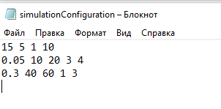
The 2nd value corresponds to gust value and 1st value to average wind speed, meaning that random generated wind speed values should be between 15-5 m/h and 15+5 m/h.
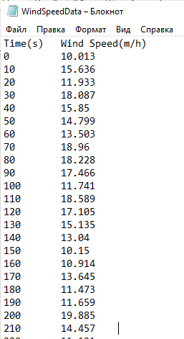
Random generated values are between 10 and 20 m/h.
Test case 1.2: Simulation duration and stepsize
3rd value corresponds to the simulation duration in hours and 4th value in the first line corresponds for stepsize value.
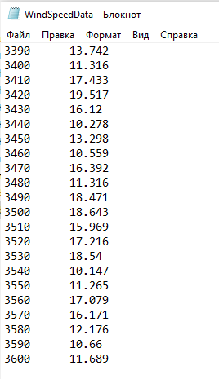
The stepsize value equals to 10 seconds and continues till 3600 seconds.
Test case 2.1: Storm probability selection
The 1st value of the second line corresponds to the storm probability.
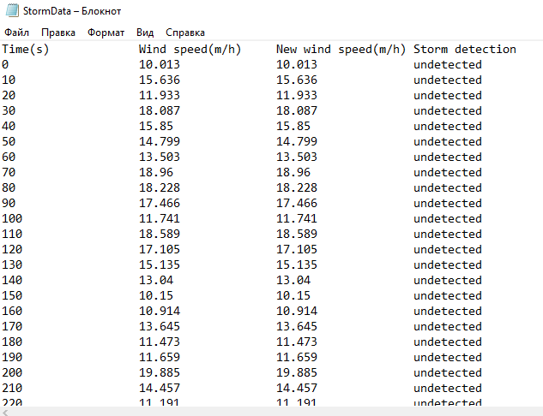
As the given probability is small and equals to 0.05 the storm is mostly not detected. However, there time durations with storm detections, which is given below.

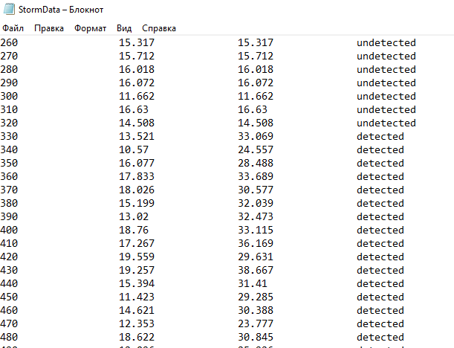
Test case 2.2: Min and max storm amplitude selection
The 2nd and 3rd values of the 2nd line corresponds to the min and max amplitude values for the storm.
When the storm is detected the random generated value between min and max storm amplitude is added to the wind speed.
Test case 2.3: Min and max storm duration
The 4th and 5th values in the 2nd line corresponds to min and max duration of storm.
When the storm is detected, its duration equals to the random generated value between min and max storm duration.
Test case 3: for checking BurstData.txt values
Test case 3.1: Microburst probability selection
The 1st value in the 3rd line corresponds to the microburst probability.
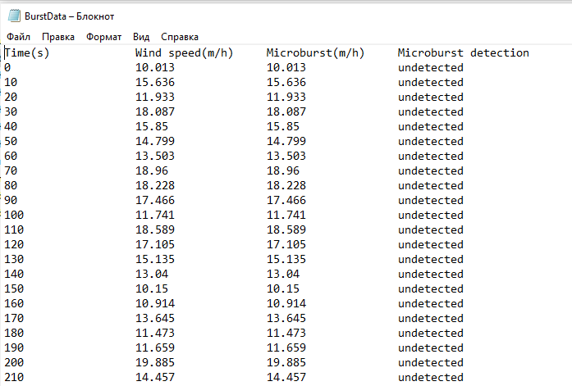
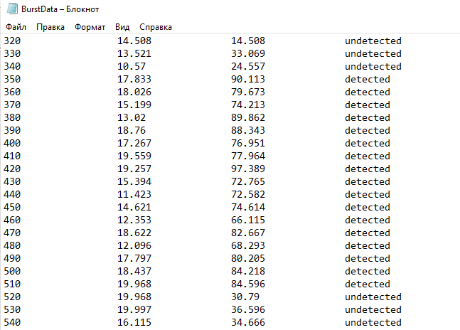
Depending on the random generated value for burst probability and given burst probability, there are some cases when burst is detected and when it is not.
Test case 3.2: Min and max microburst amplitude selection
The 2nd and 3rd values of the 3rd line corresponds to the min and max amplitude values for the burst.
When the burst is detected the random generated value between min and max burst amplitude is added to the wind speed with storm value.
Test case 3.3: Min and max microburst duration selection
The 4th and 5th values in the 3rd line corresponds to min and max duration of storm.
When the burst is detected, its duration equals to the random generated value between min and max burst duration.
User Guide
The program will help you generate simulation of wind speed data with storm and microbursts. The information is written to the file simulationConfiguration and the final result of the wind simulation is written to the WindSimulation. The values for wind speed, storm and microbursts are randomly generated.

